36. Human Disturbance of Communities and Ecosystems *(Chapters 51, 52, 54, 55)*

________________________________________________________________________

I. Introduction *(1243-1247)*

A. Oddities of Human Ecology

1. Exponential population growth – constantly

2. Top predator – top predator everywhere, hunt for sport

3. Efficient hunting / Inefficient use of prey – tool, cooperation

4. Production of wastes – produce immense quantities of novel waste products

# B. Human Disturbance of Ecosystems

-Addition of material

-Removal of material (habitat restriction)

-Changing the transfer rates between bit nutrient pools

II. Cultural (Anthropogenic) Eutrophication of Aquatic Habitats *(1212-1213, 1283-1285)*

-Nutrient enrichment

A. Sources of Materials

-Agriculture – farmers fertilize (add limiting nutrients), irrigate (aquifer)

-Run-off from irrigation carries nutrients into streams and rivers

-Pesticides and herbicides get carried by water too

-Industry – coal power plants, sulfuric acid when S0_2 mixes with water

-Acidify water (lower pH)

-Residential

-Sewage

-Detergents

-Nitrogen and phosphorus are the materials that are most often limiting

-Introduce these limiting nutrients to water through pollution

B. Consequences of Aquatic Pollution

-Add excessive nutrients 🡪

- N 🡪 K

- N > K (blooms of algae, bacteria, cyanobacteria)

-Organisms take over ecosystem

-Bacteria die in number and become a source for aerobic bacteria that decompose them

-O_2 gets depleted and animals start to die (fish/invertebrates)

-Other animals are decomposed by anaerobic bacteria (becomes the 0_2 is depleted)

-These bacteria produce H_2S as by product of respiration

1. Major pollutants

2. Human waste = fertilizer

3. Results of eutrophication

C. Eutrophication of Lake Erie

1. Background

-Detroit, Toledo, Cleveland buffalo

-40-50 billion gallons of sewage dumped in the lake each year (untreated 1960’s)

-Phosphates 🡪 1930-1970 increased 300% (2/3 from household detergent and 1/3 from agriculture)

2. History of pollution

3. Ecological effects of pollution

4. Biological, recreational, economic importance

-Planktonic algae/cyanobacteria up 20-30x

-Coliform bacteria up 3x

-Change in the bottom fauna (organisms in mud), used to have insect larvae and replaced by oligochaete worms

-Fisheries collapse, 1915 20 * 10^6 lbs fishing, 0 lbs in 1960, pollution eliminated all fish

### III. Deforestation *(1310-1311)*

A. Clearing of Tropical Rain Forests

1. Uniqueness of the biome

2. Ecological implications of large standing biomass

3. Effects of shifting agriculture

B. Desertification

### IV. Atmospheric Pollution *(1295-1297, 1301-1305, 1315-1316)*

A. Combustion of Fossil Fuels

1. Natural carbon pools

2. Incomplete combustion of fossil fuels: air pollution

3. Disruption of transfer rates among pools

B. The Greenhouse Effect and Global Warming

1. Rising CO2 levels and temperature trends

2. Consequences of warming

C. Acid Precipitation

36-1

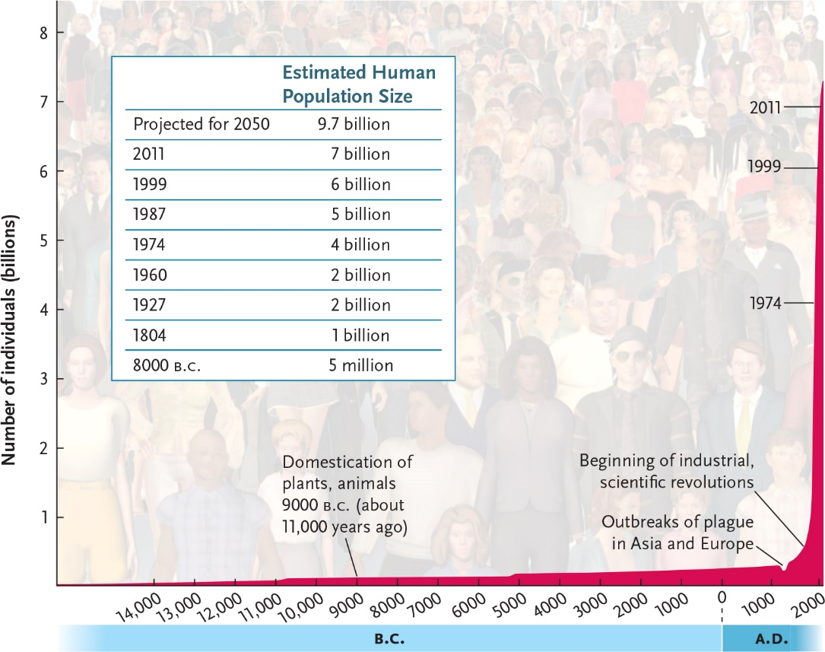

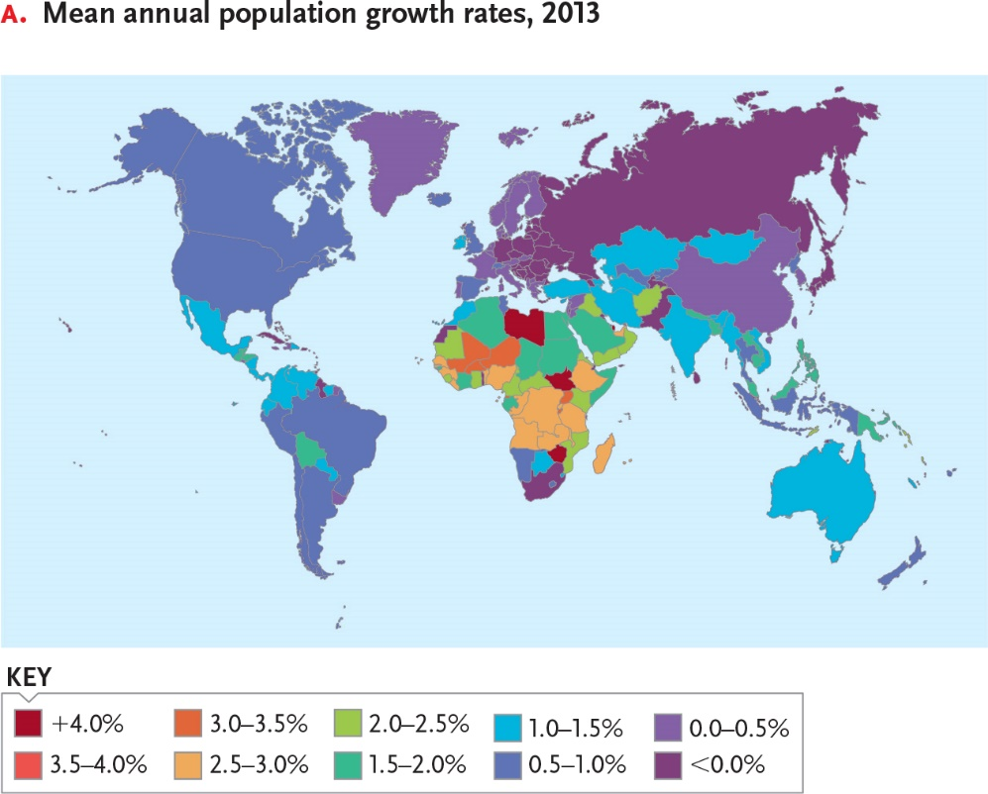

36-2

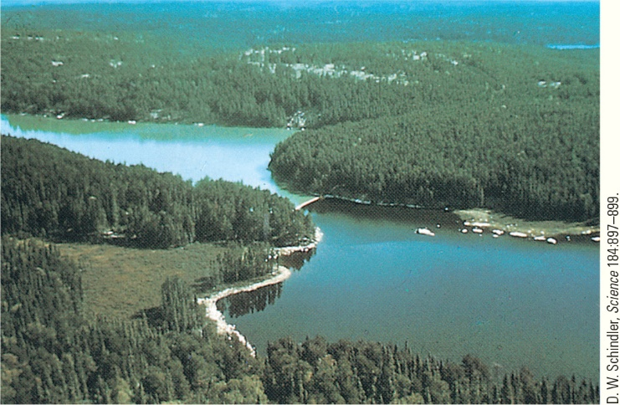

__________________________________________________________________________

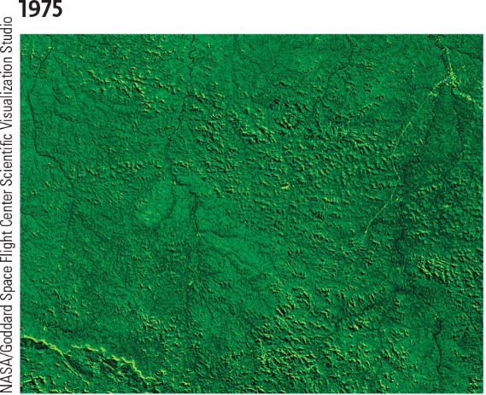 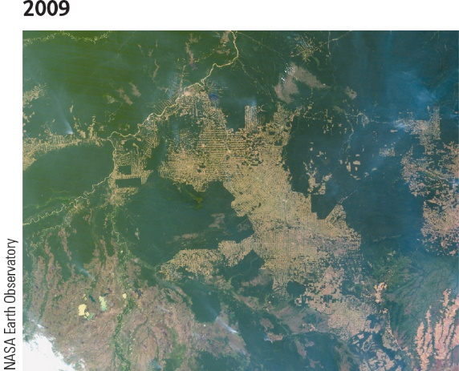

____________________________________________________________________________

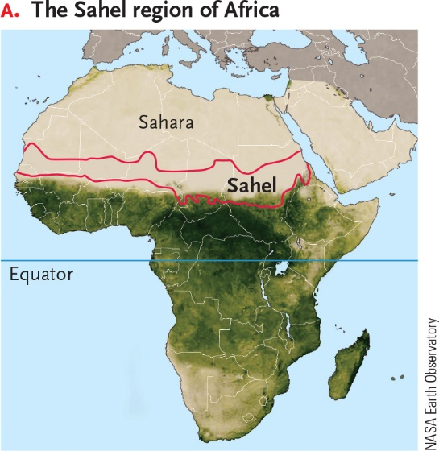 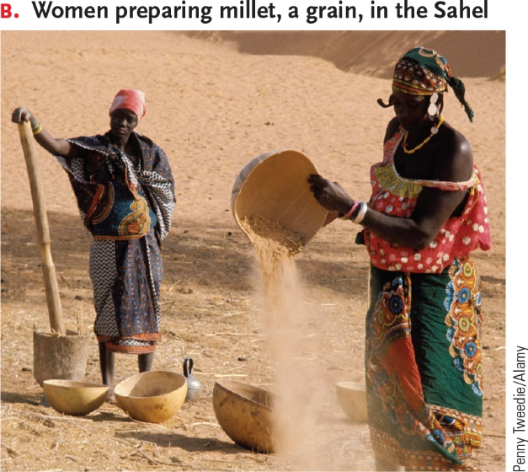

36-3

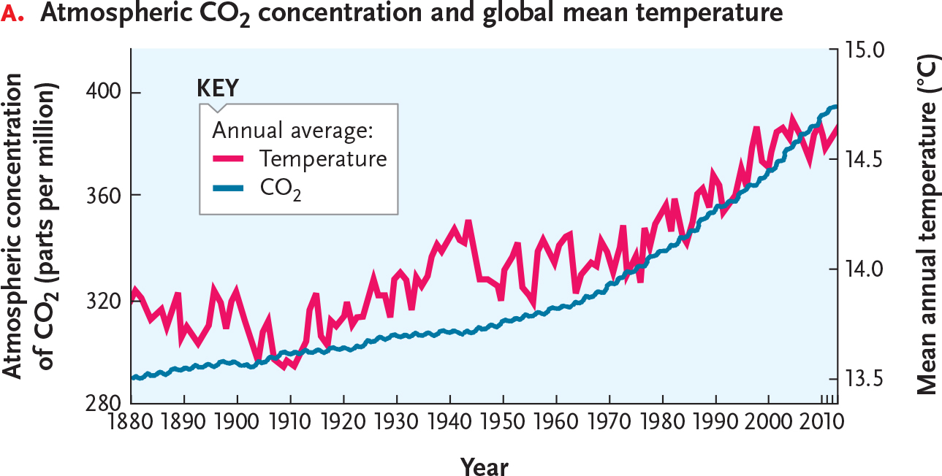

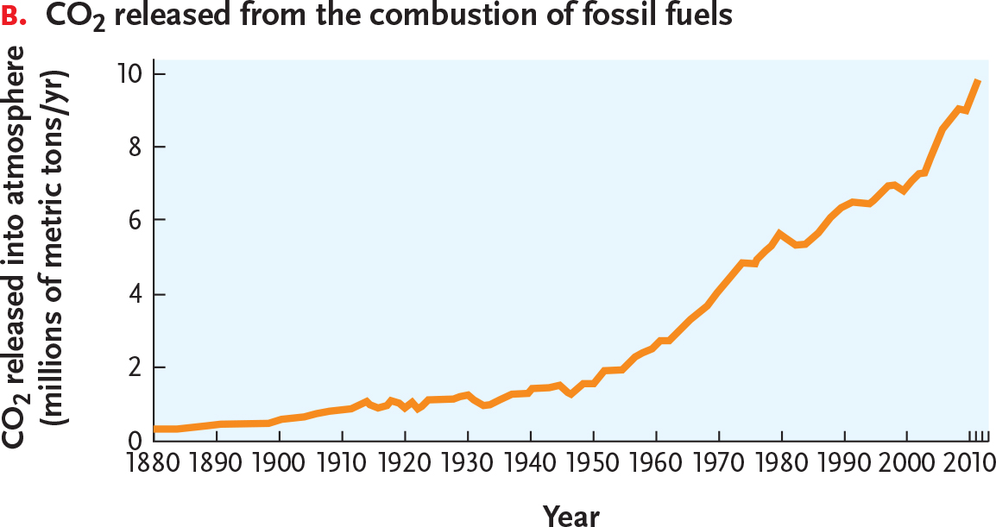

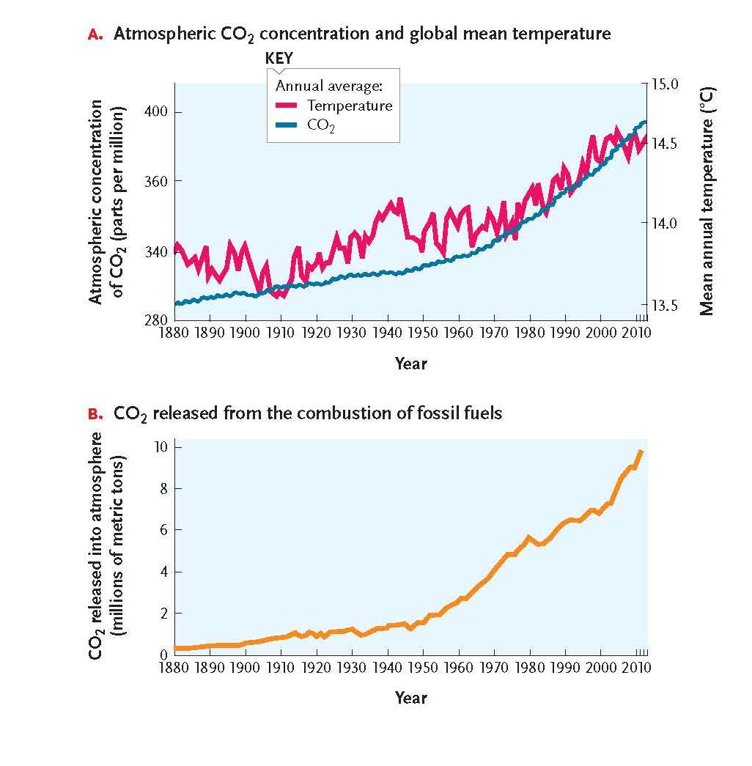

36-4

